Summer  Theme | Monday | Tuesday | Wednesday | Thursday | Friday
Future Architects | 1  Let’s Build  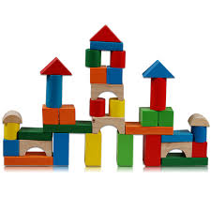  PM Ice Pops | 2  If you can dream it, you can build it so…Let’s have a Bubble Dance Party?  2:30pm | 3  Magic Show  10am | 4  Craft Day  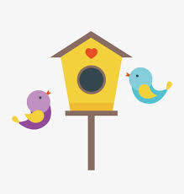 | 5  Pizza Day  Fun Friday
Future Librarians & Writers | 8  Bring in your favorite book to share! | 9  Puppets Pizzazz Show: Ocean Magic 10:15 am | 10  Royal Readers  Soft Pretzel Snack | 11  Craft Day | 12  Pizza Day  Water Play
Future Animal Welfare Professionals | 15  AWA Collection Begins | 16  Stuffed Animal Workshop | 17  Show & Share: Pet photos and books | 18  Cedar Run Wildlife Refuge 10am | 19  Pizza Day  Fun & Games
Future Performers | 22  Making the LLA Classroom Bands | 23  Mystic Drumz  10am | 24  Dress Up Dance Party and Show | 25  Water Play Day | 26  Pizza Day  Craft Day
Future Artists | 29  HOUSEL FUN FITNESS & MUSIC  (Music Program)  10am | 30  All Fired Up Painting Party | 31  HOUSEL FUN FITNESS & MUSIC  (Fitness Program)  10am | 1  LLA Art Show  Mr. Softee | 2  LLA Closed Teacher In-Service

